**JavaScript Day 2 Assignment**

Q1. What is the value of clothes [0] and why?

const clothes = [‘jacket’, ‘t-shirt’];

clothes.length = 0;

console.log (clothes [0]);

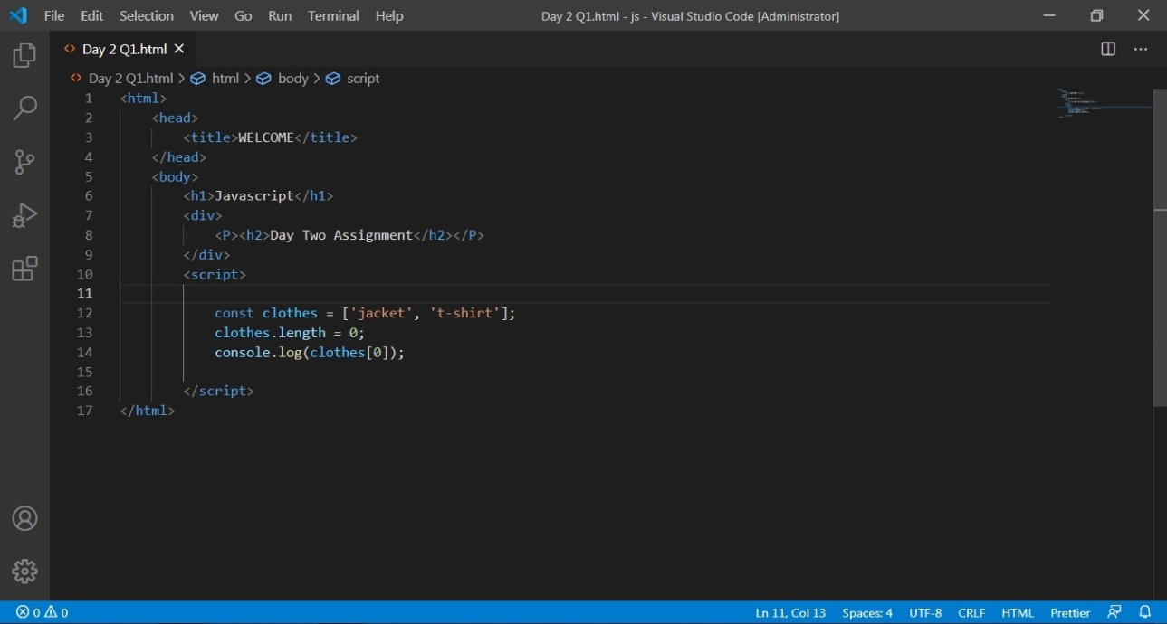

Since, the output is clothes [0]; // => undefined since cloths is now empty

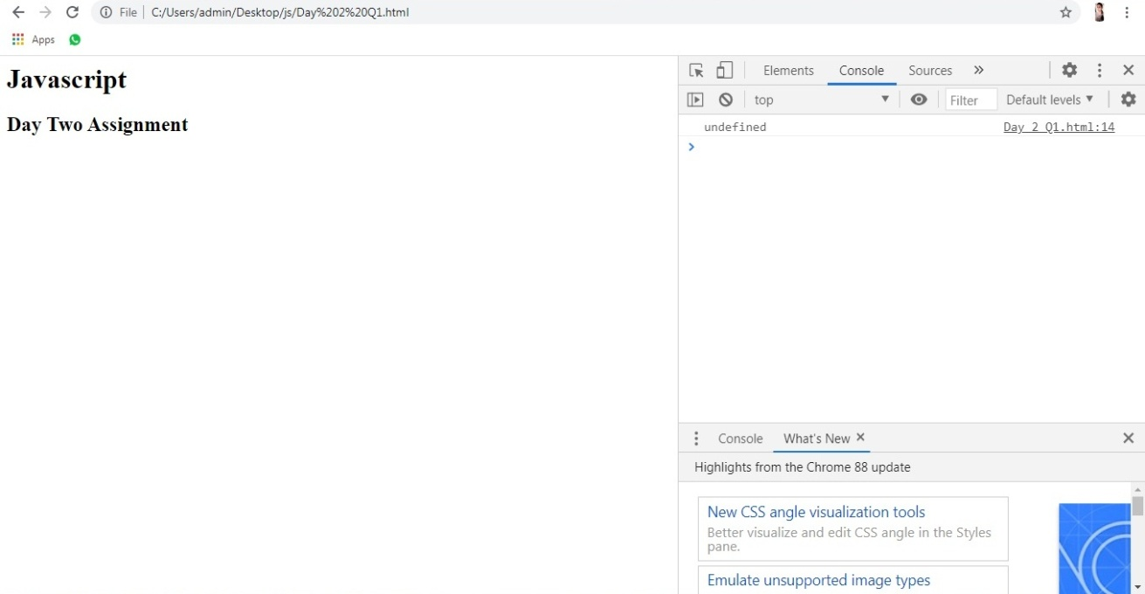

Q2. Write a java script program to find the sum of all elements of a given array?

